Presentation by Andrew Jennings

Friday 13 September, 2008

Good afternoon – I’ve been given 15 minutes to sell you the joys of investigating corruption in the international sports federations.

So, welcome to Olympic speed-dating! And I promise – NO SPORT!

We’ve got everything investigative reporters could ever dream of: Sex, drugs and sleazy billionaires, murderous dictators, money launderers, globalisation, class war and endless corruption. And much more!

But you are unlikely to read this in the sports pages. Quite right! These stories are for adults.

There’s not time now for tradecraft, for tips on how to tumble into bed with Sepp Blatter, Marion Jones or that gold medal champion at the sport of right-am raising, Franco’s favourite, the man with the best polished jackboots in the Spanish Falange, Juan Antonio Samaranch, president of the IOC from 1980 until 2001.

A fascist running world sport? Didn’t you know?

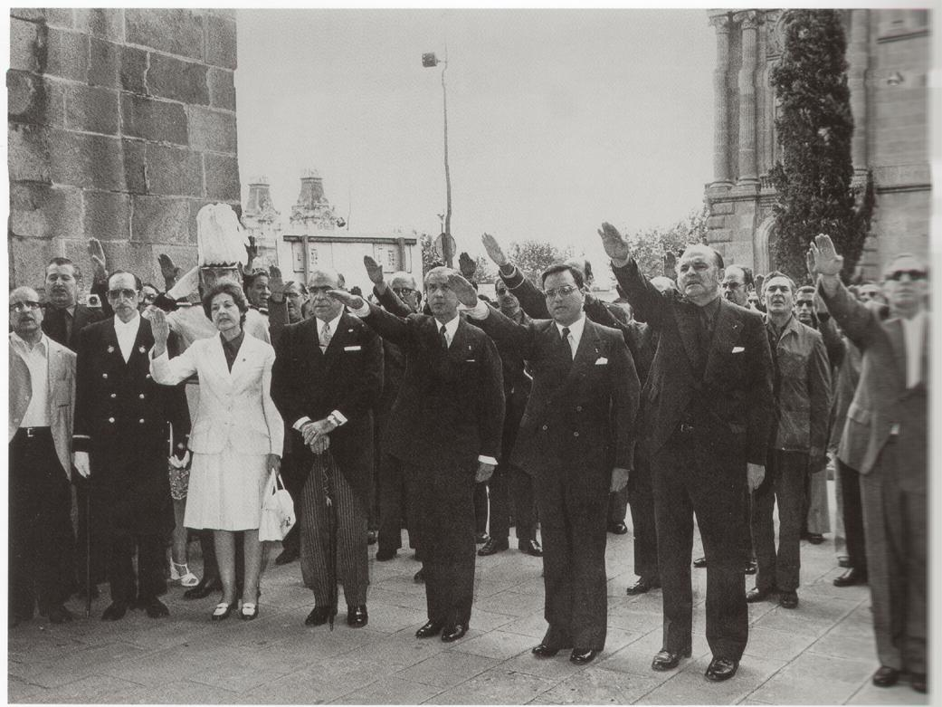

1974: IOC vice-president Juan Antonio Samaranch (4th right-arm from left) performs his favourite exercise.

Yes, world sport from Moscow in 1980 to Atlanta to Sydney and to Athens – and let’s not forget Lillehammer 1994 - was led by this strutting Nazi. It was fun discovering that – and pictures of him as a uniformed, active fascist. Does it make sense that he manipulated the IOC to give this year’s Olympics to Beijing?

And here’s a history note: You might recall that in 1989 the order to murder the students in Tiananmen Square was given by Bejing mayor, Chen Xitong. The significance of this act was recognised by President Samaranch who two years later gave him an Olympic Order, praising him as ‘an ardent defender of sport for youth.’

Others given the OO by Samaranch included Erich Honecker, Nicolae Ceaucescu, Todor Zhivkov

You’ve heard the television sports casters talk in reverential tones about ‘The Olympic Movement.’ Anybody know what that is?

I don’t. But here’s a clue. Fascism in Spain was known as ‘The Moviemento.

Samaranch did the dirty deals that privatised the Olympics and sold them off to the Biggest Global Brands.

And to make sure the deal satisfied the sponsors, the IOC suppressed positive drug tests at the Olympics, limited the supply of money to researchers devising new tests and so delivered the almost drug-free Olympics we’ve just experienced.

Here’s a little secret – don’t always suspect the athletes, it’s the blazers in the VIP seats who are on the hot sauce.

Remember the IOC cash’n’sex for votes scandal in Salt Lake City in the 1990s? Remember the cash kickbacks, the college scholarships and general extortion practised by IOC members in Utah?

But here’s one item you might have missed: they wanted more: visiting IOC members demanded that Olympic organising staff rush out to the shops to buy them a violin, a high-price vibrator and Viagra - but no drug-testing, thank you. What a party, better than any Opening Ceremony in the Bird’s Nest!

The minutes are ticking by. Do we have a date yet?

If you specialise in medical negligence – or political history here’s one to probe.

Which famous class warrior is buried in Switzerland – but had his heart ripped out and shipped to Greece for separate burial?

Yes, it’s the aristocratic Pierre de Coubertin who fought to keep women out of the Olympics and gave them to Herr Hitler in 1936. And Herr Hitler gave the IOC Karl Ritter von Halt, a Nazi party member. He was still loved in the bosom of the IOC after the war – even though Norway refused him a visa for the 1952 Oslo Winter Olympics.

The IOC’s got a new president, Belgian small-boat sailor Jacques Rogge.

In 2006 President Rogge attended a press conference of one of his sponsors. He announced, ‘McDonald’s has supported the Olympic Movement for more than 30 years now . . . and we share many of the same ideals.’

Which **can** those shared ideals be? Making young people fat? It may be a gold medal event in the new Youth Olympics they want to stage here in Lillehammer. For obese kids only. The fatter they come, the more Rogge will be pleased.

Because the IOC loves to travel first class and stay in the best hotels, Rogge and his IOC members have to say these things if they are to maintain the regular deluge of cash. They know the rules of Olympic sport.

These rules were spelled out by Coca-Cola Vice-president Mr John Hunter. He told an Olympic conference, ‘Just as sponsors have the responsibility to preserve the integrity of the sport so too you have responsibility and accountability to the sponsor.’

But ‘sponsor’ sounded too vulgar. Now they are called ‘partners.’

Sure, there’s criticism of the IOC for signing up with make-you-fat-McDonalds and rot your teeth Coke.

But the biggest Olympic sponsor offers something for everyone here. The IOC loves the huge American conglomerate General Electric. And GE help fund conferences about the laughable Olympic Truce.

But it would have been a disaster for GE if there had been one last month. GE make the jet engines for most of the airplanes bombing civilians in Iraq and Afghanistan. A truce would have been bad for business.

One of the biggest elements of the GE empire is money-lending. They’ve been big in the subprime mortgage racket in America and in Europe. Despite some problems, GE loansharking made $100 million dollars profit last year.

And to make sure that telling the Olympic story is in safe hands, GE owns NBC who have the TV rights to the American market. To keep the IOC in line, GE even has their own IOC member, NBC vice-president Alex Gilady.

When the Olympic brand was in trouble after the Salt Lake scandal - who sorted it out?

In came Henry Kissinger whose company advises many of these multinational sponsors. With him came PR company Hill & Knowlton who devised the so-called ‘Reform Programme.’ They made the Olympics safe for the brands.

Finally – who are the IOC? Idi Amin’s former army commander General Francis Nyangweso is still there – he’s on their commission for culture and Olympic education. Sitting next to him is the member known to women employed by Olympic bidding cities as Mr Wandering Hands. Their complaints are about harassment are ignored by the IOC.

The IOC was forced to bid farewell Indonesia’s Bob Hasan, the world’s biggest rain-forest logger when the post Suharto courts jailed him for theft of public funds. And it was goodbye too for the world’s richest man, who had bulldozed the delicate ecology of the Japanese Alps to build winter sports resorts for himself and the Nagano games of 1998 and contributed millions to Samaranch’s Olympic museum. They gave Yoshiaki Tsutsumi a Gold Olympic Order and made him an Honour Member. That was revoked in 2005 after Tokyo fraud detectives had cause to visit his office, unannounced.

And there’s only 15 women in the IOC ranks.

* * * * * * * * * * *

I’m running short of time – so here’s FIFA really high-speed dating. FIFA give you such fun – because after a while – they hate you with a raging bitterness. Ask Jens

They’ve stolen my phone records, spied on me at public conferences like this; spread vile rumours.

Come with me and explore FIFA’s grotesque mis-management, vast corruption, *much worse than the IOC*.

A recent court case in Switzerland revealed that a handful of senior official at FIFA stole in excess of $100 million from money paid by sponsors. And senior executives from the world’s biggest advertising agency – Japan’s Dentsu – extracted huge kickbacks and stowed them in a Hong Kong bank account.

Senior FIFA officials are the biggest ticket racketeers at the World Cup. They divert thousands of World Cup tickets and sell them on the black market.

Like the IOC they ban me from their press conferences – threatening their staff never talk to you – and then can’t understand why your files are overflowing with their most confidential documents.

And here’s what they said when the IFJ asked why I was banned:

“FIFA is under no compulsion to enter into discussions with or answer journalists who scathingly oppose FIFA and severely violate the basic principles of proper journalism to produce sensational and biased reports. There are limits to which all journalists must adhere.

“In FIFA’s opinion ‘Press Freedom’ is not absolute.”

Read more at:

http://[www.transparencyinsport.org](http://www.transparencyinsport.org)